1 Hour and 30 minutes

THE UNIVERSITY OF MANCHESTER

EART26201 Principles of Geochemistry

?? June 2024

Time: ??:?? - ??:??

Answer ALL questions in the booklets provided.
Clearly label which question each of your answers corresponds to. All writing must be LEGIBLE. Illegible documents cannot be marked.
There are 100 marks available on this paper. The number of marks for each question is shown and may be used as a guide to how much time you should spend on each.
You may wish to use labelled sketches to illustrate your answers where appropriate.
The use of calculators is permitted, as long as they cannot store text, perform algebra and have no graphing capability.

© The University of Manchester, 2023

Question 1

Komatiites are MgO-rich magmatic rocks that mostly formed in the Archean (~3 Ga) when the mantle was much hotter than it is today. The crystallisation of these MgO-rich magmas can be roughly described using a phase diagram in the fayalite-forsterite system, where forsterite (Fo) is Mg-rich olivine and fayalite (Fa) is Fe-rich olivine. Compositions are summarised in terms of the proportion of Fo present (X_{Fo}).

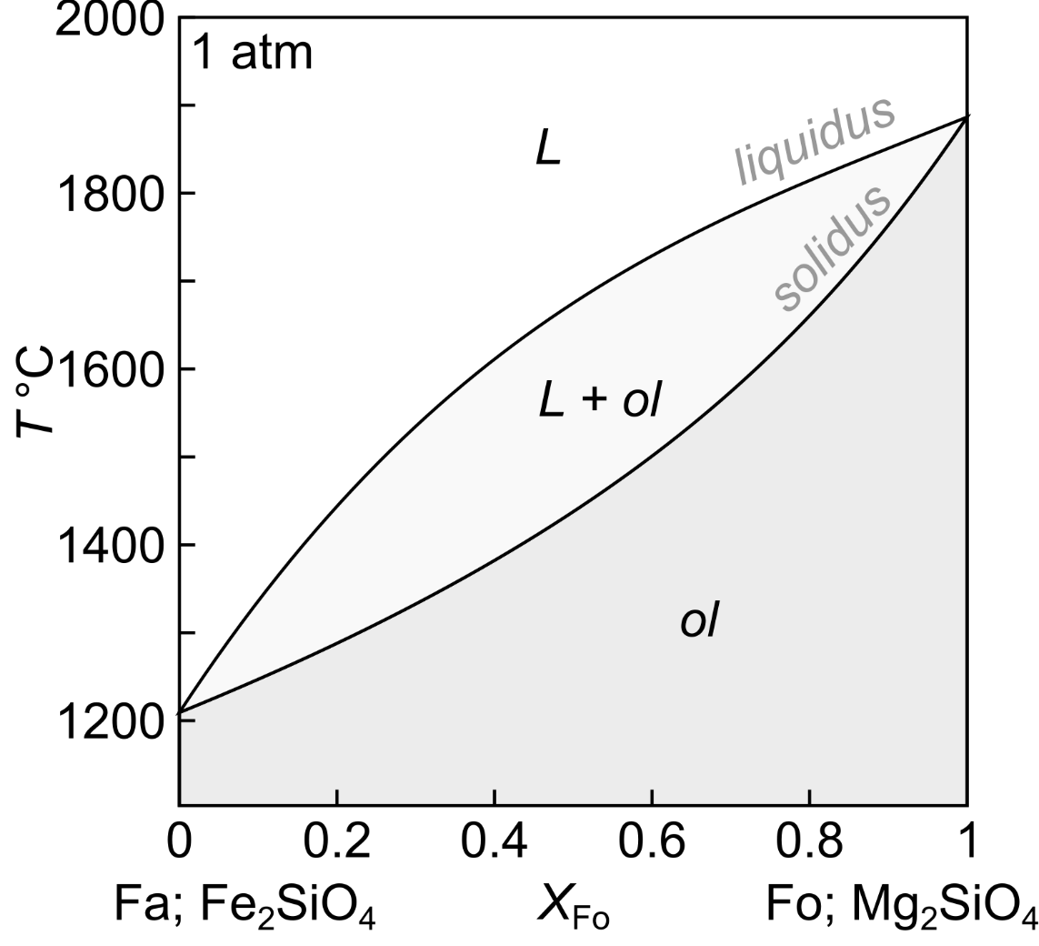

- Komatiites crystallised olivine when they erupted onto the Earth’s surface. With respect to the Fa-Fo phase diagram, quantitatively describe what happens when a komatiite-like melt with a composition of X_{Fo} = 0.8 undergoes:
- equilibrium crystallisation. [10%]
A melt with XFo=0.8 will start to crystallise at ~1820 °C, producing olivine with a composition of XFo~0.93. As the system cools, the melt and olivine will become progressively more Fe-rich until the olivine has a composition of XFo=0.8 when the melt has a composition of XFo~0.45 at ~1650 °C when the system is fully solidified. Top marks could be achieved for using the lever rule to describe the system state at some point during cooling.
- fractional crystallisation. [10%]
The first olivine crystals produced during fractional crystallisation will have the same composition as those produced by equilibrium crystallisation (XFo~0.93) and will form at the same temperature (~1820 °C). However, these olivine crystals will be removed from the system as soon as they form, which will lead to the melt evolving all the way to pure Fa (XFo=0) at 1220 °C as cooling proceeds, producing a series of crystals with compositions ranging from XFo~0.93 to XFo=0.
- Komatiite samples typically contain uniformly Fo-rich olivine crystals (X_{Fo} > 0.9). Do these olivine crystals record the full cooling history of the komatiites they were erupted in? Explain your reasoning. [5%]
Regardless of whether they evolve by equilibrium or fractional crystallisation, komatiites should generate olivines with a small or large range of XFo contents, respectively. This means that homogenous olivine crystals do not record the full cooling history of the komatiites. For full marks the students may explain compositional homogeneity being the result of diffusive re-equilibration.
- The Rayleigh fractionation equation describes how the concentration of an element in a liquid ($C_{l}^{liquid}$) evolves with respect to the concentration in the initial liquid ($C_{0}^{liquid}$) as a function of the melt fraction remaining ($F$) and partition coefficient ($D_{i}$):
$$\frac{C_{l}^{liquid}}{C_{0}^{liquid}}=F^{\left(D_{i}-1\right)}$$
Given that komatiites initially contain ~2000 µg/g Ni and that $D_{Ni}=5$ for olivine-melt system, quantitatively explain why economically important Ni deposits are more likely to be associated with primitive magmas ($F\sim 0.9$) than evolved magmas ($F\sim 0.5$). Given that $D_{Co}=3$ and $D_{Cr}=0.6$, comment on whether Ni deposits associated with komatiites are more likely to contain economic quantities of Co or Cr. [15%]
D | 5
C0 | 2000 | Cl
F | 0.9 | 1312.2
F | 0.5 | 125
Ni is compatible, meaning that it is removed from melts as crystallisation proceeds – after 10% fractional crystallisation, komatiites contain 1300 ppm, but this decreases by an order of magnitude after a further 40% crystallisation (for 50% in total), to 125 ppm. This means that economic quantities of Ni are more likely to be accumulated in minimally crystallised Ni-rich magmas like komatiites. Co is similarly compatible to Ni, so will behave in a similar way. Cr, in contrast, is incompatible in an olivine-melt system, so will be progressively concentrated in the melt. Komatiite-associated Ni deposits are th8us more likely to contain economic quantities of Co than Cr.
- Compositionally zoned olivine crystals are commonly found in basalts. This zoning often reflects the partial re-equilibration of crystals transferred between different magmas by diffusion. With reference to the Fa-Fo phase diagram, diffusion theory and the three composition profiles given for three different olivine grains from different basalts below, comment on:
- whether the zoning for each profile reflects transfer into hotter or cooler magmas. [5%]
Profile 1 moved from a hotter to a cooler magma (higher to lower XFo), while Profiles 2 and 3 moved from a cooler to a hotter magma (lower to higher XFo)
- the relative timing of the transfers recorded by the different profiles. [5%]
Profile 2 is the shallowest and longest, and therefore oldest. Profile 1 is the steepest and shortest, and therefore youngest. Profile 3 is intermediate.

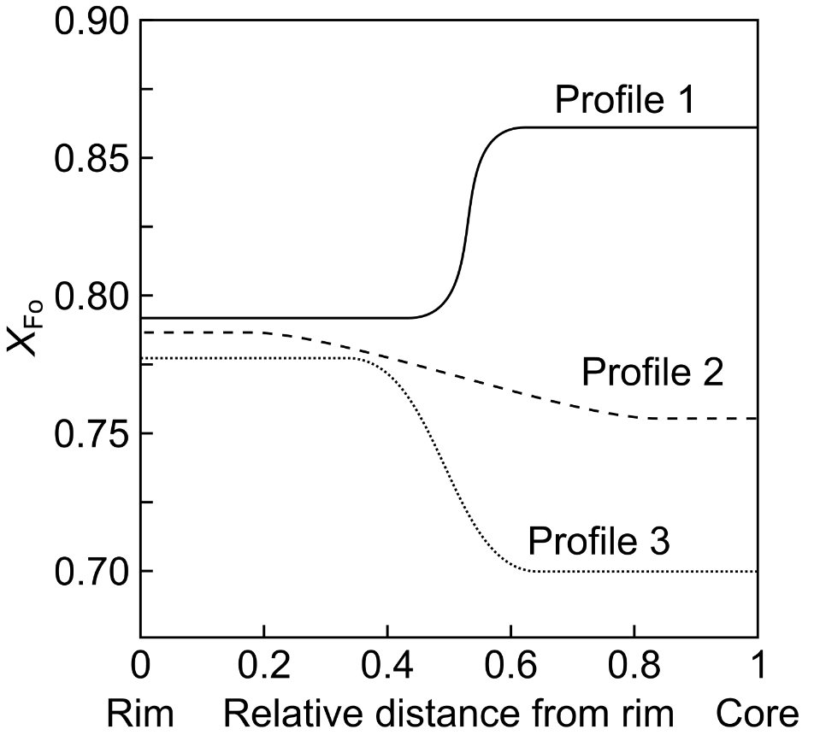

Question 2

The solubility product (Ksp) of calcite and siderite are 3x10⁻⁹ and 3x10⁻¹¹ respectively so siderite will preferentially replace calcite. Assuming the concentration of Fe²⁺ ions is negligible (i.e. [Ca²⁺] + [Fe²⁺] ~ [Ca²⁺]) calculate the concentration of Fe²⁺ ions in solution in the presence and absence of Ca2+ ions. What is this effect called? [25%]

Because the solubility of calcite is >> siderite and [Ca²⁺] >> [Fe²⁺]
Then approximate [Ca²⁺] + [Fe²⁺] ~ [Ca²⁺]
So: [Ca²⁺] ~ [CO₃²⁻]
Since K_{sp} = [Ca²⁺][ CO₃²⁻] = 3 × 10⁻⁹
[Ca²⁺] = [CO₃²⁻] = sqrt(3 × 10⁻⁹) 5.5 × 10⁻⁵ mol/L
Substitute this concentration into: [Fe²⁺][CO₃²⁻] = 3x 10-11
And rearrange equation gives [Fe²⁺] = 3x 10-11 / 5.5x10-5 = 5.5x10-7 mol/l in presence of calcite
And [Fe²⁺] = sqrt(3x 10-11) = 5.5x10-6 mol/L in the absence of Calcite
This is the common ion effect.

Question 3
How and why does the redox state (eH and pH) differ between deep surface and shallow/surface fluids? [25%]

Redox linked to Pourbaix diagrams > pH v pE. Oxygen controls redox at surface, hydrogen controls redox deeper. Redox determines oxidation state and pH determines species solubility and formation of insoluble oxides (and hydroxides). In general, environments in contact with the atmosphere (e.g. rainwater, oceans, streams) have higher pE and / or pH than environments isolated from the atmosphere (e.g. peat bogs). This makes sense if we think about the actual partial pressure of oxygen in the atmosphere (PO2 = 0.21) – this is much nearer to the upper stability limit of water than the lower stability limit. In most natural waters redox conditions are controlled by oxygen, sulphur and iron.

END OF EXAMINATION PAPER

Document tracking sign off table

Please fill out form at each stage of process so the process can be tracked

Stage | Role | Name | Signature | Date
1. Question setting | UC
2. Internal Review | IM
3. Address Internal review | UC
4. External Examiner review | EE
5. Address external review | UC
6. Final check of print out | UC
UC = unit coordinator; IM = internal moderator; EE = External examiner.

